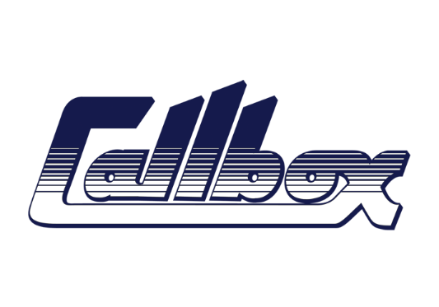

CALLBOX: 01932 592 572

www.callboxdiary.com

**Hugo Foley Mobile: 07984367257 Email: Hugofoley@gmail.com AD Department**

**Commercials & Digital Content**

**PRODUCTION COMPANY PRODUCT Director 1st AD POSITION**

Bellhouse H&M Johnny Dufort James Sharpe 3rd AD

Sliced Beavertown We Are Tobin Spencer Wilson 2nd AD

Another Asda Brad Lubin Sam Dawking 3rd AD

Merman Sainsburys Guy Manwaring James Sharpe 3rd AD

Merman Dettol Ben Liam Jones Clara Paris 3rd AD

Biscuit Monzo Andreas Nilsson Joe Carter 3rd AD

Academy Google Pixel Jack Driscoll Clara Paris 3rd AD

Shoot Europe Marriott Westin Inge Prins Hugo Foley 1st AD

Thursdays Child Air BNB Wendy Huynh Hugo Foley 1st AD

Somesuch BBC Dan Emmerson Clara Paris 2nd AD

Charlotte Tillbury Charlotte Tillbury Joseph Salah Clara Paris 2ND AD

Soft Target Under Armour Colin Renshaw Joe Carter 3rd AD

Merman Pepsi Nicole Akermann Clara Paris 3rd AD

Charlotte Tillbury Charlotte Tillbury Joseph Salah Clara Paris 3RD AD

Arts & Science Service Now Matt Aselton James Sharpe 3RD AD

Charlotte Tilbury Charlotte Tilbury Joseph Salah Clara Paris 3rd AD

Arts & Science ServiceNow Matt Aselton James Sharpe 3rd AD

Stink Marks & Spencers Colin Solal Cardo Danny Rumberlow 2nd AD

Partizan Beefeater Camille Boumans Clara Paris 3rd AD

Charlotte Tilbury Charlotte Tilbury Katya Ganfield Clara Paris 3rd AD

Somesuch EE Dan Emmerson Clara Paris 3rd AD

Lucky Strike Lancome Carla Guler Clara Paris 2nd AD

Somesuch EE Caleb Femi Clara Paris 3rd AD

Stink William Hill Tom Green Sam Dawking 3rd AD

Stink Sky Glass Traktor Jim Cole 3RD AD

Charlotte Tilbury Charlotte Tilbury Katya Ganfield Clara Paris 2ND AD

Academy St James Place Frederic Planchon Jim Cole 3RD AD

Sweetshop Voltarol Liz Murphy Clara Paris 3RD AD

MJZ Uber Eats Craig Gillespie Alex Oakley 3rd AD

Smuggler Shelter Max Weiland Clara Paris 2ND AD

Iconoclast JD Sports Christmas Amara Abbas Jim Cole 3rd AD

Creators Inc McDonalds Ninian Doff Jim Cole 3rd AD

Smuggler Google Pixel Fenn & Henry Clara Paris 3rd AD

Mai Productions Diesel Cody Baker Clara Paris 3rd AD

Canada Adidas Lou Escobar Joe Carter 3rd AD

Voodoo Pictures Jaeger Le Coultre Adrien Wagner Tom Kelly 2ND AD

SKY Creative SKY/ KICK IT OUT Glenn Kitson Clara Paris 3rd AD

Amazon Amazon Stephanie Sian Smith Shane Ryan 3rd AD